EMPLOYEE UPDATE FORM

Please complete the following information (insert why you want to update the employee information). Please note, all information provided will be kept in the strictest confidence as per the applicable privacy legislation. Only those employees who require access to this information will be provided with it.

**Personal Information**

| **Full Name:** |
| --- |
| **Personal Email Address:** |
| **Home Address:**  **Street: ________________________________________________________**  **City: ___________________________ Province: ______________________**  **Postal Code: ______________________** |
| **Phone Number(s):**  **Cell phone: ___________________**  **Home phone: ___________________** |

**Banking**

Please provide your banking information for payroll, or attach a void cheque. Please note you can usually obtain your account information within your online banking, by viewing a cheque, or directly from a bank teller. See the sample image below for further information.

| **Bank Name (or 3-digit Institution Number):** |
| --- |
| **Transit Number (5-digits):** |
| **Account Number:** |

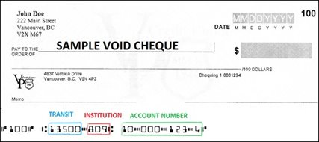

**Emergency Contact Information**

Please complete the following form so that we know who to contact on your behalf in the event of an emergency.

**CONTACT 1**

| **Name:** |
| --- |
| **Relationship to you:** |
| **Phone Number (s):** |
| **Email Address:** |

**CONTACT 2**

| **Name:** |
| --- |
| **Relationship to you:** |
| **Phone Number (s):** |
| **Email Address:** |